
Introduction to Electrical Engineering
Lab Report
Name: Pranesh Chowdhury
ID: 202003112
Course ID: 112
Section: 2
Experiment No: 4
Experiment Name: Verification of KVL and KCL

Objective:
In this experiment, Kirchhoff’s Voltage Law (KVL) states that the algebraic sum of the potential raises and drops around a closed-loop is zero. The sum of the rises around a closed loop must equal the sum of the drops in potential.
Σ V (rises) = Σ V (drops)
Kirchhoff’s Current Law (KCL) states that, in a closed circuit, the entering current at the node is equal to the current leaving at the node.
Σ I (entering) = Σ I (leaving)
List of Equipment:
- Wires
- Resistors
- PSIM Software
- DC Power Supply
- Ammeters
- Voltmeters

Circuit Diagram:
1st Circuit:
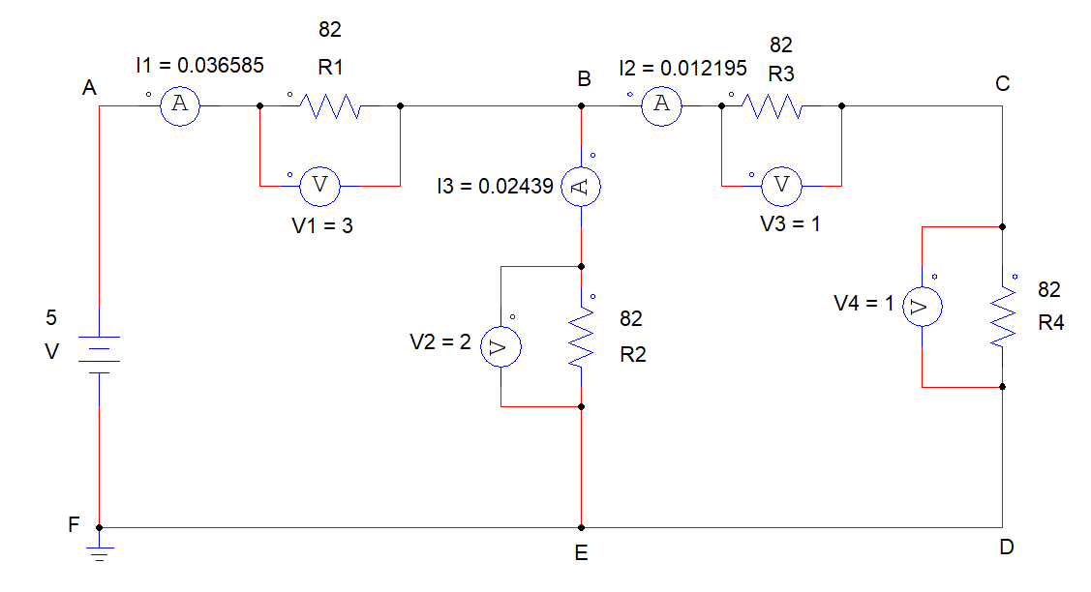
2nd Circuit:
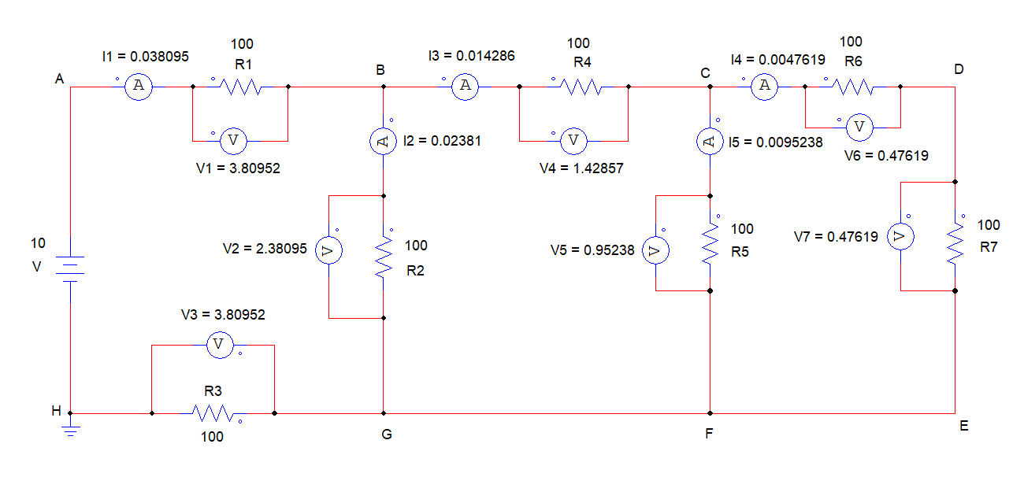

Data Table:
Data Table of the 1st Circuit -
Voltages |  | Currents
V1 | 3 | I1 | 0.036585
V2 | 2 | I2 | 0.012195
V3 | 1 | I3 | 0.02439
V4 | 1

Data Table of the 2nd Circuit -
Voltages |  | Currents
V1 | 3.80952 | I1 | 0.038095
V2 | 2.38095 | I2 | 0.02381
V3 | 3.80952 | I3 | 0.014286
V4 | 1.42857 | I4 | 0.0047619
V5 | 0.95238 | I5 | 0.0095238
V6 | 0.47619
V7 | 0.47619

Result:
1st Data Table result –
Kirchhoff’s Voltage Law (KVL):
ABEFA: E1-V1-V2=0
- 5-3-2=0
BCDEB: V2-V3-V4=0
- 2-1-1=0
ABCDEFA: E1-V1-V3-V4=0
- 5-3-1-1=0

Kirchhoff’s Current Law (KCL):
1st Node: I1=I2+I3
- I1-I2-I3=0
- 0.0365885-0.012195-0.02439=0

2nd Data Table result –
Kirchhoff’s Voltage Law (KVL):
ABGHA: E-V1-V2-V3=0
- 10-3.80952-2.38095-3.80952=0
BCFGB: V2-V4-V5=0
- 2.38095-1.42857-0.95238=0
CDEFC: V5-V6-V7=0
- 0.95238-0.47619-0.47619=0
ABCDEFGHA: E-V1-V4-V6-V7-V3=0
- 10-3.80952-1.42857-0.47619-0.47619-3.80952=0

Kirchhoff’s Current Law (KCL):
1ST Node: I1=I2+I3
- I1-I2-I3=0
- 0.038095-0.02381-0.014286=0
2nd Node: I3=I4+I5
- I3-I4-I5=0
- 0.014286-0.0047619-0.0095238=0

Discussion:
In this experiment, we verified the Kirchhoff’s Voltage Law (KVL) and Kirchhoff’s Current Law (KVL). The two circuits are used for verifying the law. For this experiment, we used PSIM software tools. The voltage law states that the algebraic sum of all the voltages around any closed loop in a circuit is equal to zero. The current entering must equal the leaving current.

